# JS Advanced: Exam 19.11.2018

# Problem 4. Darts

Write a **JavaScript** **program** that **simulates playing a Dart** and **keep tracking** the **players scores**.

Use the **index.html** and **app.js** **files** to solve this problem.

**Note:** You **can't** and you have **no permission** to change directly the given html code (index.html file).

### Submission

You should **submit only** the **app.js file**

### Expected functionality:

This problem is quite like a **darts game**, when a **layer** of the **dartboard** is **hit**, its **points** are **added** to the **total number of points** of the current player.

**The outermost layer** is the **first one** and gives **the least points**, and the one in **the middle** is the **last one** which gives the **highest number of points**.

Players are **alternating** and each time they have **only one** shooting option. **During each turn** it should be **clear** **which** of the two players **is in turn** and who **is** **after**.

Also, as mentioned above, **the total number of points** **for both players should be monitored**, **after each turn** you should **add** the **points** from **the hit layer**.

**The points** for **each of the layers** can be seen from the **scoreboard**. The information about each of the layers and the points is given in ascending order by color. The first one is the first layer, the last one is the middle layer.  
**Keep in mind that** every test will have **six layers** **with the same sequence of colors** (green, yellow, orange, red, purple, blue), as shown below in the examples and in the skeleton itself, **BUT** ***the value of the points in each layer (color) will be different!***

**That means you need to get the value of points for each layer (color) by accessing the item containing this information** **but not to be taken literally / directly as a value from the example that is shown.**

**The winner** is this player who **first gets 100 points** or **more. This means the end of the game**, in which case the **dartboard must stop functioning** unless it is restarted. In other words, if either player makes 100 points or more, then if a given layer/color is scored, points **should not be scored**.

**It also needs to be clear which player has won!**

The players who played is **Home** and **Away.**

The game always starts with the Turn on Home.

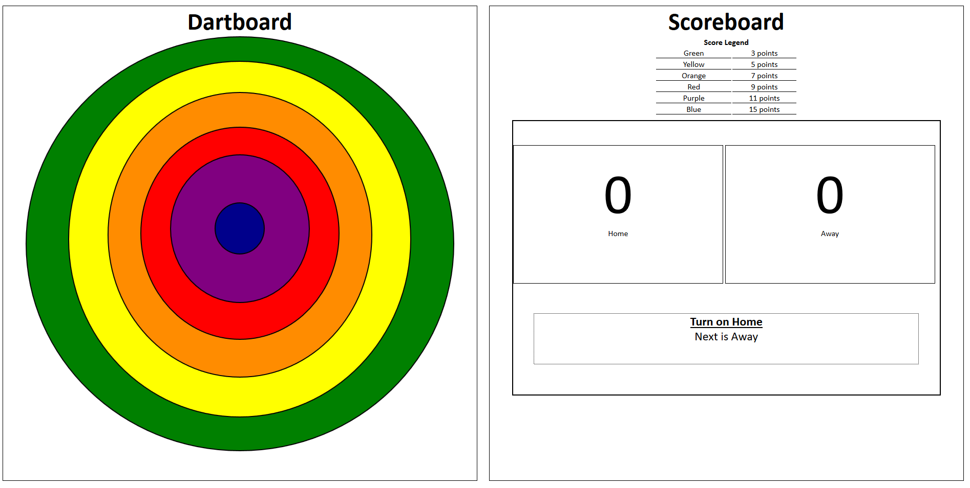

### Example

When we have this **score legend:**

First layer: Green -> **3** points  
Second layer: Yellow -> **5** points  
Third layer: Orange -> **7** points  
Fourth layer: Red -> **11** points  
Fifth layer: Purple: -> **13** points  
Sixth layer: Blue - > **15** points

And for instance if the current player (**Home**) hit the **yellow layer**, the expected result must be:

**The scores** for the **hit layer** must **added** to the **total number of points** on that player and the two players must be **switched** (**Turn on Away**, **Next is Home**)

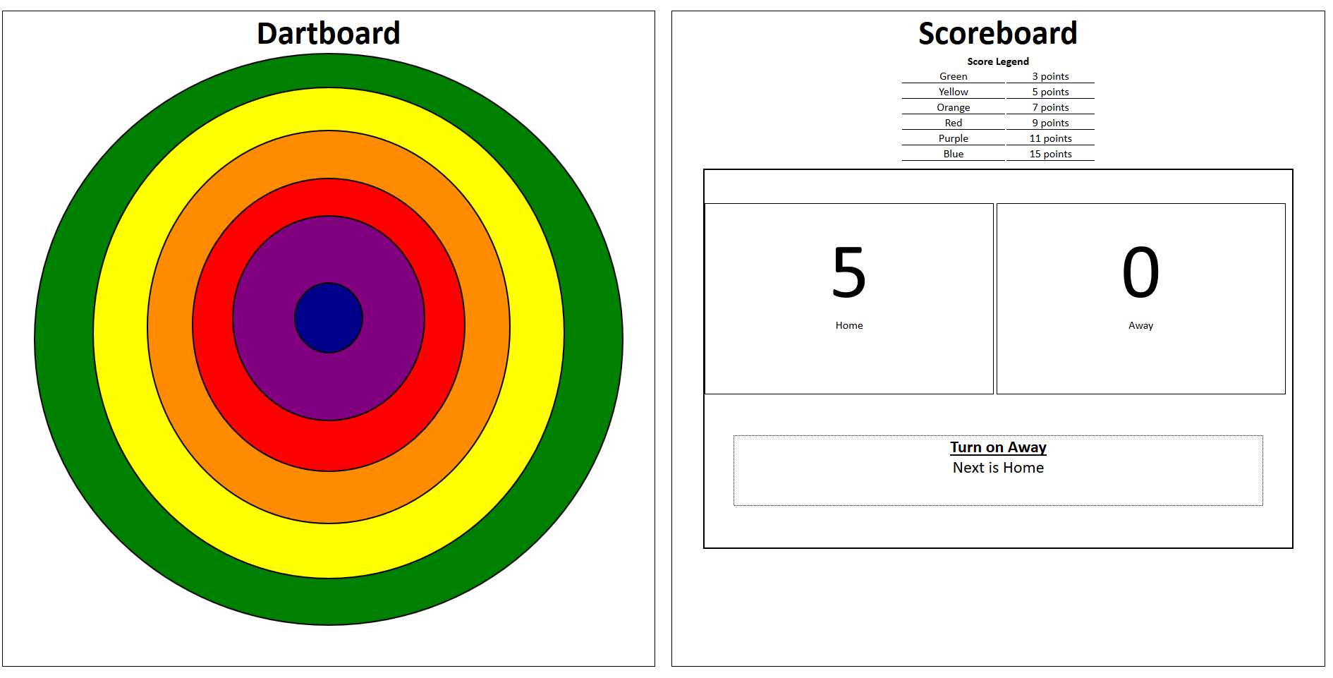

Now, if the current player (**Away**) hit the **red layer**, the expected result must be:

The **points of the Away** should be **9 and the turn has to passed to the "Home":**

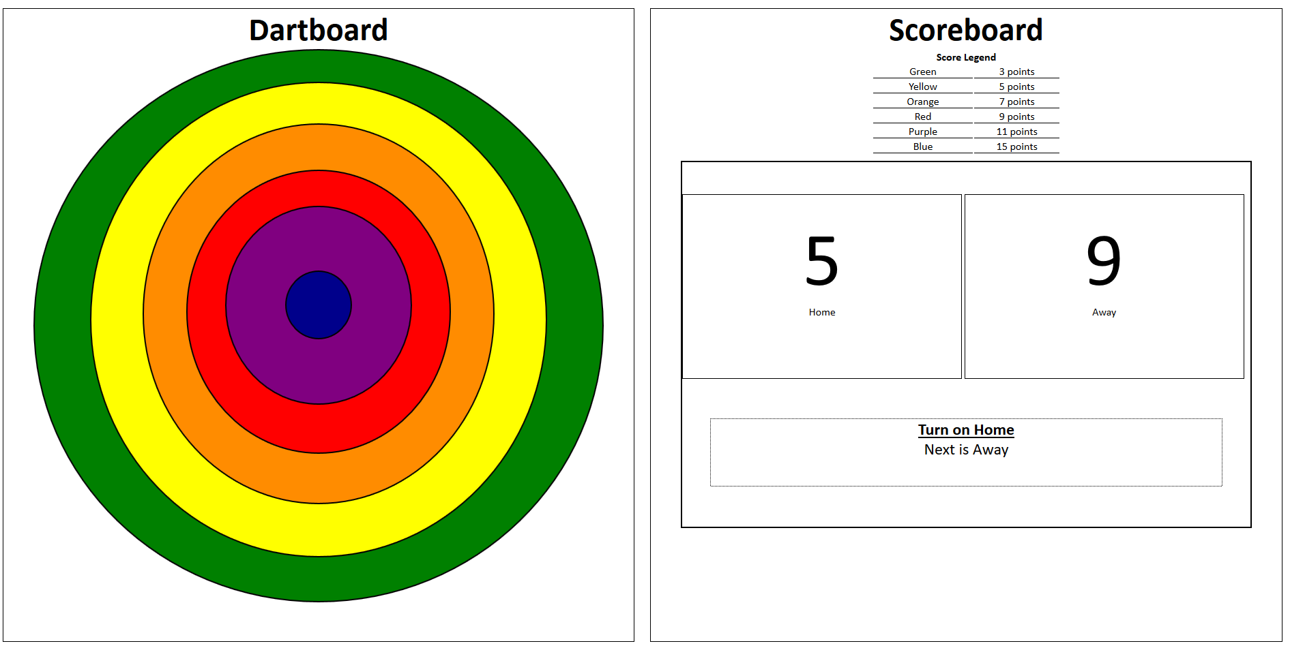

An example of what is expected to happen if a player is **victorious**:

If we had the current **score legend:**

First layer: Green -> **10** points  
Second layer: Yellow -> **20** points  
Third layer: Orange -> **30** points  
Fourth layer: Red -> **40** points  
Fifth layer: Purple: -> **50** points  
Sixth layer: Blue - > **70** points

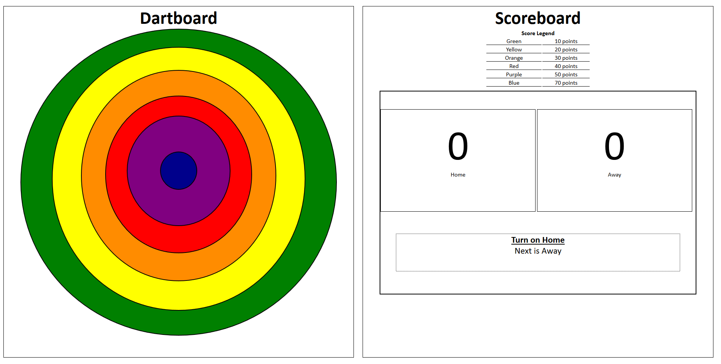

In this scenario, if **each player** **has made 3 shots** with shots **being better** than the **previous** **one** with the **other player**:

A hit history led to the final result below:

Home hit **first layer** -> Home 10, Away 0  
Away hit the **second layer** -> Home 10, Away 20  
Home hit the **third layer** -> Home 40, Away 20  
Away hit the **fourth layer** -> Home 40, Away 60  
Home hit the **fifth layer** -> Home 90, Away 60  
The lasts shot to the board is from **Awa**y, he hit **the sixth layer** (the blue one) and he gets the max points which is **70**.

**The final result** is Home 90 vs Away 130, which means **Away** **is the winner!**

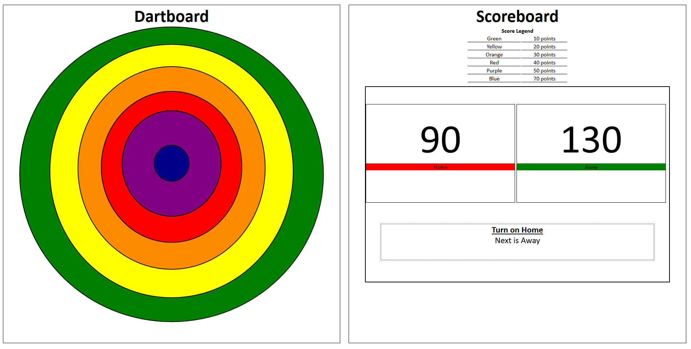

### Sample document skeleton

**Dartboard:**

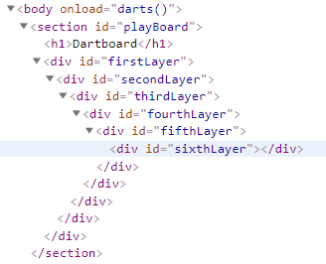

**Scoreboard:**

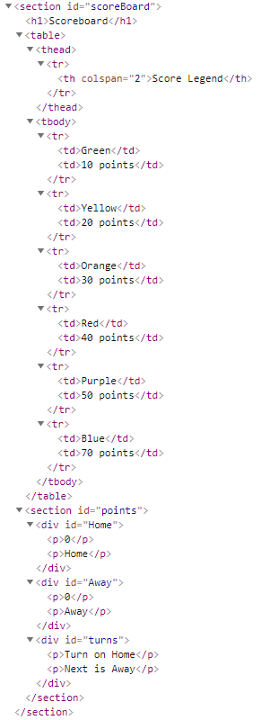

### When player won the game

